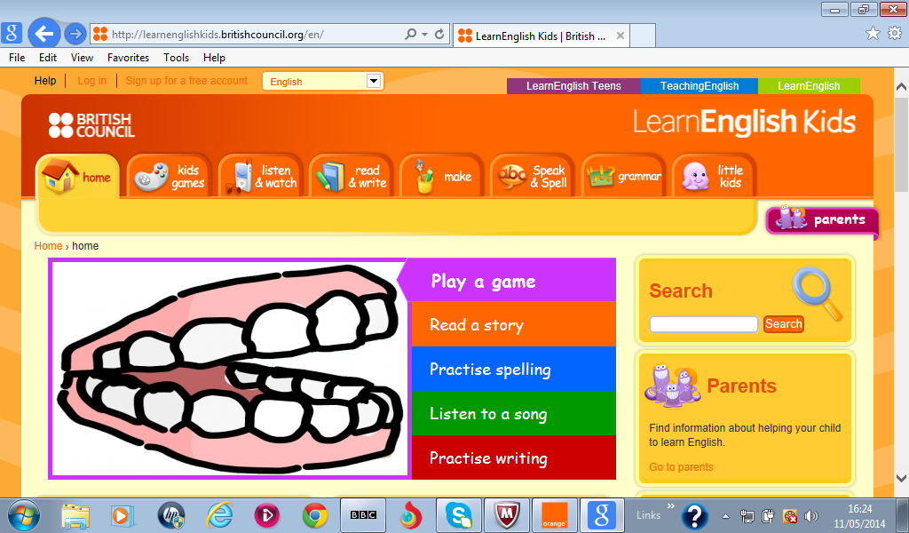
LearnEnglish Kids webquest
Full name ………………………………………… (Parents’)Tel Number……………………….
(Parents’) Email address…………………………………………….
To enter this English Language Month webquest competition, complete the personal details above, then visit Learn English Kids http://learnenglishkids.britishcouncil.org/en and find the answers to the 5 questions below. Write your answer for each question. Save this document and send it to English4future@tn.britishcouncil.org by Sunday 22 November 2015.

1.Click listen and watch then The River. Listen to the song.   | Where is the river?  ……………………………………..
2. Click the read and write section then Pencil Case.   | How many questions are there about your pencil case?  ………………………………………….
3. Click the make section and craft downloads. Go to spider mobile.   | How many spiders are in the mobile?  ………………………………………
4. Click the speak and spell section. Go to spell. Go to The Birthday Party. | Sam and Pam think that Ben and Tess look _ _ _ _ _.
5. Click the grammar and then grammar games. Play the modals game.   | The opposite of must is _ _ _ _ _’ _
Good luck!

