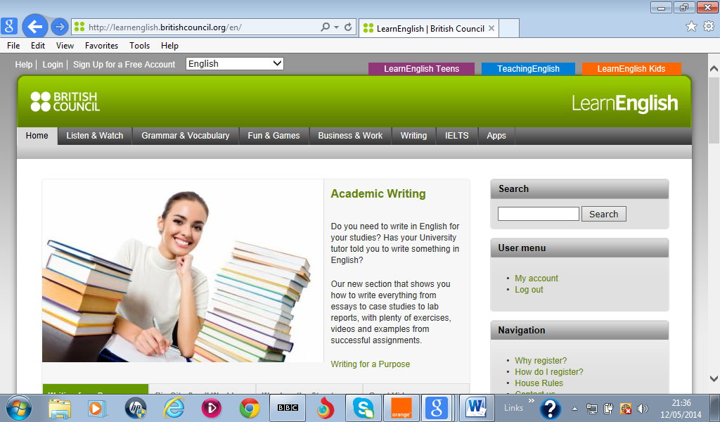
Learn English webquest

Full name ………………………………………… Tel Number……………………….
Email address…………………………………………….
To enter this English Language Month webquest competition, complete your personal details above, then visit Learn English website http://learnenglish.britishcouncil.org/en & find the answers to the questions below. Write your answer for each question in the box. Save this document and send it to English4future@tn.britishcouncil.org by Sunday 22 November 2015.

1.Click on Listen & Watch section & UK Culture. Go to Currency. | Does the UK use the Euro?  ………………………………………….  What does ‘p’ stand for?  ………………………………………….
2. Click on the Grammar & Vocabulary section, and Vocabulary Games. | Which game uses four buttons to make any English tense or verb?  ……………………………………………………….
3. Click on Business & Work section. Go to the You’re Hired videos. Watch episode 10. | How many people will Sarah manage?  …………………………………………
4. Click on the IELTS section. Go to Mock Listening Paper-American Literature. | Edgar Allen Poe is best known for tales of:  …………………………………………..
5.Click on the Apps section. | Which Learning App is useful for people who drive a car for a living?  ……………………………………………..

Good luck!

