EU4Y - Youth Voices Forum

This programme is for Tunisian youth, “EU4Youth,” aiming to contribute to the improvement of the economic, social, and political inclusion of the most disadvantaged young Tunisians through a local development approach.
The Youth Voices Forum is a series of regional and national forums which will gather young people and decision-makers across the country to discuss young people’s needs and priorities in relation to culture, creation, and sports. The aim of these forums is to place marginalized young people at the Centre of the EU4Youth process and enable them to influence the conceptualization and the design of the programme. Findings from the YVF will inform the EU4Youth programme’ s thematic priorities and approaches.
If you are interested, please find the following link where details of the tender are available in addition to all documents that can be downloaded.
https://in-tendhost.co.uk/britishcouncil/aspx/ProjectManage/2358
In order to view and apply for the tender please follow below steps.

- Create a log in on Intend Portal - Please note that only yellow fields are mandatory for registration information on the portal.

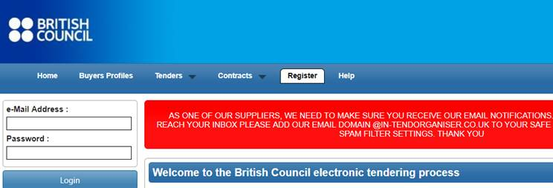

2- Click on Current under Tenders Tab;

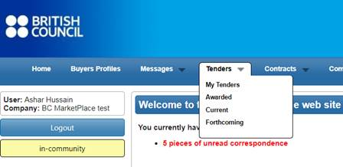

3- Click on the project title
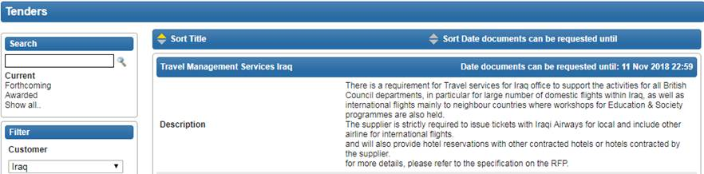

4- Click on Express Interest button at bottom



5- You will be able to view all the Project Details and documents under ITT

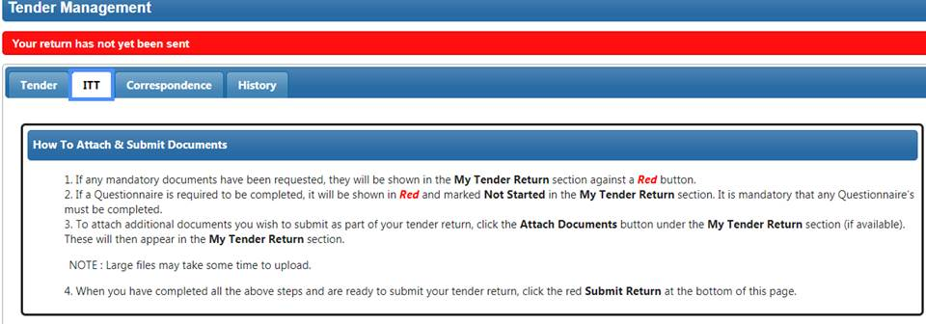

6- In order to submit your proposal, attach your proposal and Bid Value click on Submit Return button.

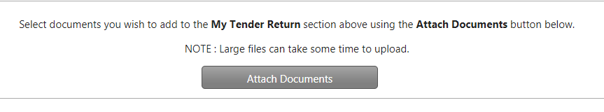
7- In case you want a clarification please send your correspondence to us by clicking on Correspondence Tab

